Understanding the difference between policy, process, and procedure

Policy qualities
- Policies are the business rules and guidelines of a company that ensure consistency and compliance with the company’s strategic direction. The Policies lay out the business rules under which a company, division, or department will operate.
- Policies are the guidelines under which Procedures are developed. There is not a one-to-one relationship between a Policy and a Procedure. Policies are not part of the Procedure, because they cannot be properly structured. However, the Procedure must reflect the business rules contained in the Policies.
- Policies address what the Policy is and its classification, who is responsible for the execution and enforcement of the Policy, and why the Policy is required.

Process qualitites
- Processes are related activities that produce a specific service or product (example, Procurement to Payment). The majority of Processes cross departments or functional areas. Each Process designates the connect points and where it crosses department lines. The documentation presents the total Process. It is helpful to be able to reference or drill down to the applicable Policy or Procedure for a Process step. A Process map is a useful tool to graphically display the Process.
- Processes indicate where there is a separation of responsibilities and control points. They are also very helpful to identify Policy and Procedure requirements. Processes address who is responsible to perform the Process (department, division),what major functions are performed, and when the function is triggered.

Procedure qualities
- Procedures define the specific instructions necessary to perform a task or part of a Process. Procedures can take the form of a work instruction, a desk top Procedure, a quick reference guide, or a more detailed Procedure.
- Procedures usually are structured by subject (for example, system instructions, report instructions, or Process tasks). A Procedure usually addresses only a single task. This separation enables Procedure components to be compiled into special Procedure manuals for specific audiences, end users, and purposes.
- Procedures detail who performs the Procedure, what steps are performed, when the steps are performed, and how the Procedure is performed.

http://kcggroup.com/PoliciesProcessesProcedureDifferences (link may not be live)
Updated link:
https://www.sweetprocess.com/what-are-the-differences-between-a-policy-a-process-and-a-procedure-why-knowing-this-is-the-key-to-scaling-and-automating-your-business/
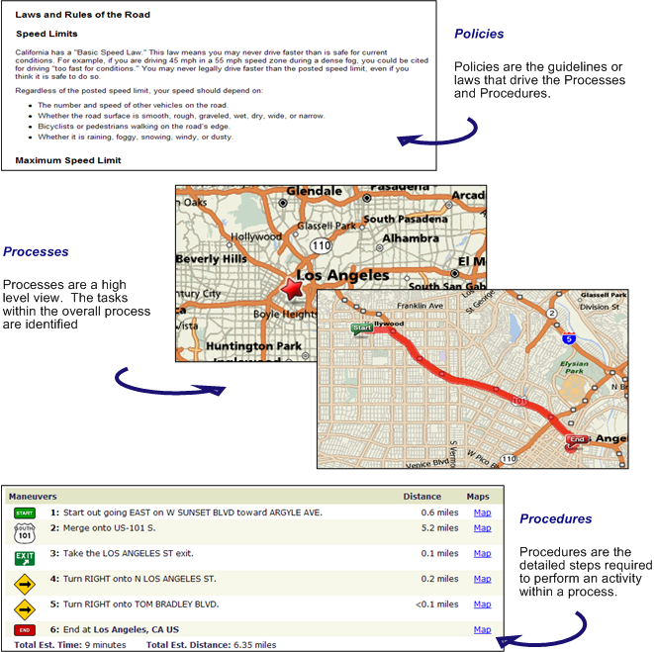

Credit:
http://kcggroup.com/PoliciesProcessesProcedureDifferences

